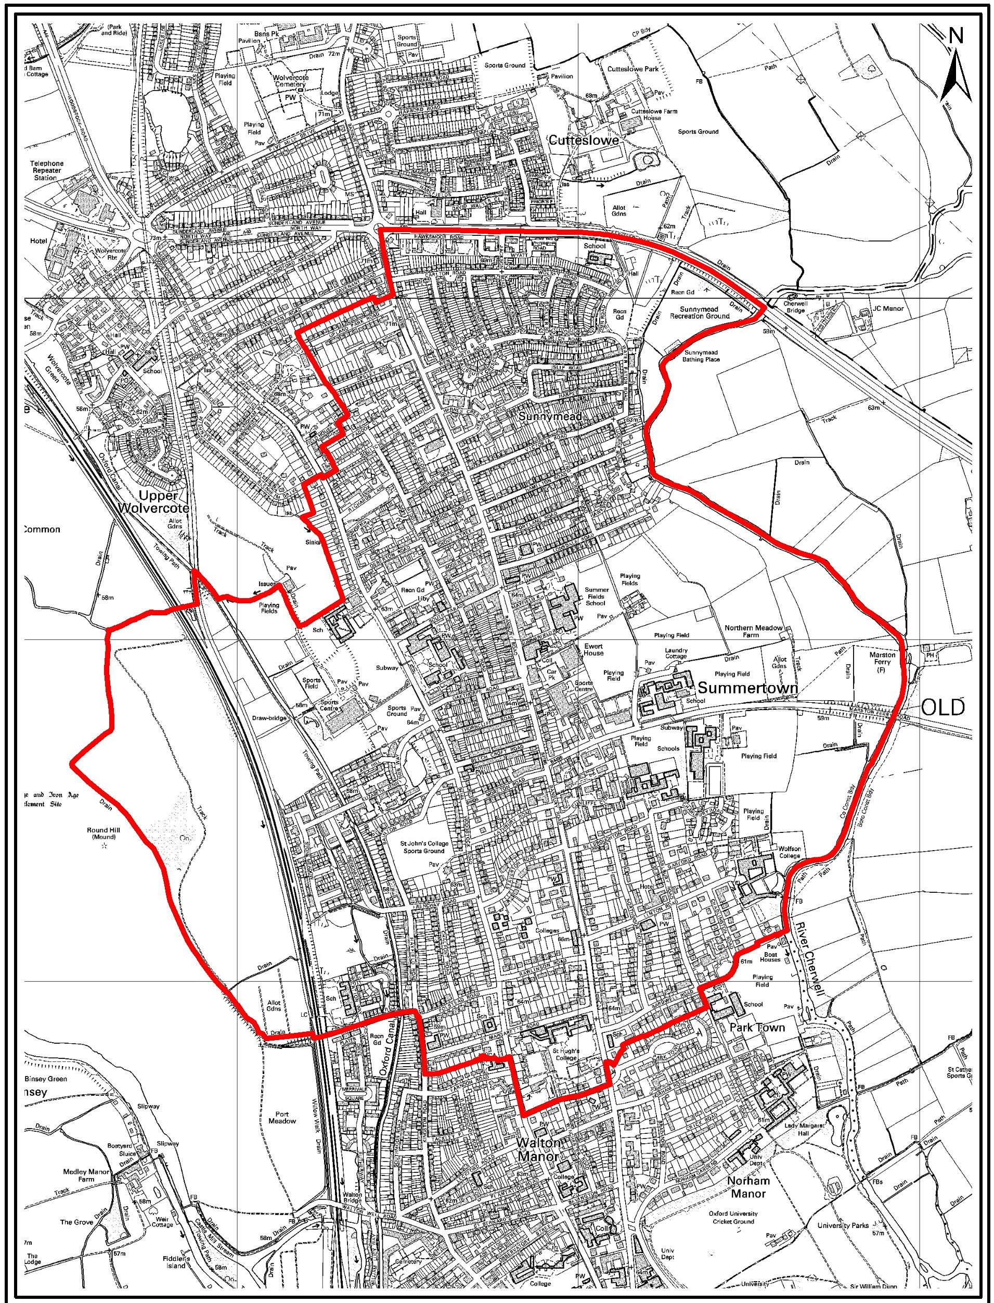
Map of Summertown and St Margaret's Neighbourhood Area

0---1.:2:5::2::5=0===:5J00
Metres
©Crown Copyright and database right 2011. Ordnance Survey 100019348. 1:15,000

:g
1

: 0
CITY
COU NCIL

